Blackview BV9900E

Type of device: Mobile
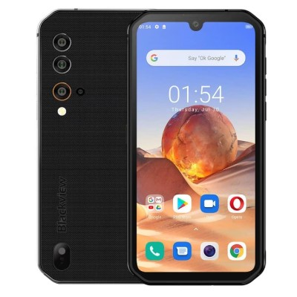

Actual Display Size : 5.84 inches
Button Type : Touchscreen
Operating System : Android
Version Number : Android 10
Network Capability : 3G,4G
Year of Release : 2020
Average Price : $599 as of 08 07 2021

Accessibility Features:

Cognitive
- Additional Instructions
- Copy and Paste
- GPS
- Photo Telephone List
- Screen Timeout Disabled
- Simple Instructions
- Simple Reminders
- Simplify Display
Voice Notes

Hearing Impairment and Deaf
- Allows for sign language communication
- Bluetooth or Wi-Fi
- Closed Captioning
- Front Facing Camera
- Text Messaging/SMS
- Video Communications - Two-way
Visual Alerts - Incoming Calls

Vision
- Battery Alert - Audible
- Bluetooth or Wi-Fi
- Brightness Adjustable
- Dictation / Speech-to-Text
- Personalised Shortcuts
- Power Cue
- Screen Magnifier
- Screen Reader
- Text Size Adjustable
- Voice Control /Personal Assistant
Voiced Menus

Speech
- Allows for sign language communication
- Bluetooth or Wi-Fi
- Messaging Options - Email
- Messaging Options - IM
- Messaging Options - MMS
- Predictive Text
SMS Personalisation and Reuse

Physical
- Automatic Answer
- Bluetooth or Wi-Fi
- Dictation / Speech-to-Text
- Gesture Based Navigation
- Predictive Text
- Speaker-phone option
- Switch control option
- Voice Control / Personal Assistant
- Voice Recognition for Accessing Features
Voice Recognition for Dialling

How and where to get it from?
You can buy this phone from Rugged Phone Store, and other retailers.

More information is available on:
Blackview BV9900E Webpage

